Ignition Advanced Reporting User Manual (Site Engineer) v1
  - EEPL-UM-Ignition Advanced Reportung-v1

Date Created: 2026 July 20th
Author: Sek Jian Wei

SNMP DRIVER

App & Project Engineers Manual
  - License the module, create an SNMP Device Connection, diagnose status, and configure dynamic OID OPC Tags.

Use this guide when: the SNMP Driver module is installed and you need to place a new SNMP device into service.
Item | Details
Audience | Application & Project Engineers
Platform | Ignition 8.3 Gateway and Ignition Designer
Document revision | Rev 1.0 — 22 July 2026
Example Gateway | http://localhost:8088 (replace localhost with the actual Gateway address)

Contents
Use the main chapters in order. Open the appendices only when you need an exact setting, status, or error code.
Section | What it helps you do
How to use this manual | Understand the four-stage workflow and basic words.
Before you start | Collect Gateway, network, security, and OID information.
1 License the SNMP Driver | Download machine information and upload the returned license JSON.
2 Create an SNMP Device Connection | Choose SNMP Device and enter the correct connection/security settings.
3 Confirm and Diagnose | Interpret status, Diagnostics nodes, Tag Quality, and Gateway logs.
4 Create an OPC Tag | Create the Designer tag and enter its OPC properties.
5 Dynamic OID | Choose syntax, access mode, SNMP type, Ignition type, and polling rate.
6 Write to an SNMP OID | Understand every write gate and perform an approved write safely.
7 Troubleshooting | Work from symptom to exact cause and collect escalation evidence.
8 Site Completion Checklist | Confirm the connection is ready for handover.
Appendices | Look up connection limits, license status codes, and Tag Quality codes.

How to use this manual
Follow Chapters 1 to 5 for a normal new installation. Use the later reference tables only when you need to choose an OID type or solve a fault.
FIELD RULE: Never guess an OID, security credential, or write permission. Obtain these from approved device documentation or the Project Lead.
Security: This manual does not publish passwords, SNMP secrets, or production IP addresses. Use approved credentials supplied for the site.

Four things you will complete
Stage | You will do | Done when
1. License | Download machine information, obtain a license JSON file, then upload it. | License page shows LICENSED.
2. Connect | Create an SNMP Device Connection with the correct version and credentials. | The connection is saved and has no configuration error.
3. Diagnose | Read the device status, diagnostics tags, Tag Quality, and Gateway logs. | You can identify where a problem occurs.
4. Create Tag | Enter a dynamic OID OPC Item Path in Designer. | The tag receives a value with Good quality.

Quick workflow
Install module → License page → Device Connection → OPC Tag → Confirm Good quality

Words used in this manual
Term | Plain meaning
Gateway | The Ignition server web page where modules and device connections are managed.
Designer | The Ignition application used to create projects and Tags.
SNMP | A protocol used to read or write values in network devices.
OID | The numeric address of one value inside an SNMP device.
OPC Tag | An Ignition Tag that reads a value from an OPC UA device.
Dynamic OID | An SNMP OID entered directly in the OPC Item Path. The driver creates it when the tag is requested.
Community | A shared SNMP v1/v2c access secret. Treat it like a password.
SNMPv3 security | A user name plus optional authentication and privacy settings.
Tag Quality | Ignition's indication of whether a tag value is trustworthy and current.

Before you start
Collect the following information from the Project Lead, device supplier, or approved device documentation.
- Ignition Gateway address and an account allowed to configure the Gateway.
- SNMP device host name or IP address and UDP port (normally 161).
- SNMP version: v1, v2c, or v3.
- For v1/v2c: Read Community; and Write Community only if writing is approved.
- For v3: Security Name, Security Level, authentication details, privacy details, and Context Name if used.
- The numeric OID, required data type, and polling rate for each point.
Network check: The Gateway computer must be able to reach the SNMP device. Firewalls and network rules must allow SNMP traffic.
Do not test with guesses: Repeated wrong SNMPv3 credentials can trigger security alarms or temporary lockout on some devices.

Example addresses
Item | Details
Local test Gateway | http://localhost:8088
Site Gateway example | http://<gateway-host>:8088
License page | http://<gateway-host>:8088/app/snmp-driver/license

Login: Use the Gateway account supplied for the site. Do not place the Gateway password inside a report, screenshot, or project note.

1 License the SNMP Driver
Licensing identifies the Gateway computer. An external licensing person or licensing program creates the license file. The Site Engineer only downloads machine information and uploads the returned JSON file.

1.1 Open the License page
STEP 1 — Open the Gateway
In a browser, open the Gateway address and sign in with the approved Gateway account.
STEP 2 — Open SNMP Driver License
Use the left navigation to open SNMP Driver, then select License. You may also open /app/snmp-driver/license after the Gateway address.
STEP 3 — Read the status
Look at License Status. If it already shows LICENSED, continue to Chapter 2.
Expected result: LICENSED means the driver is allowed to run.
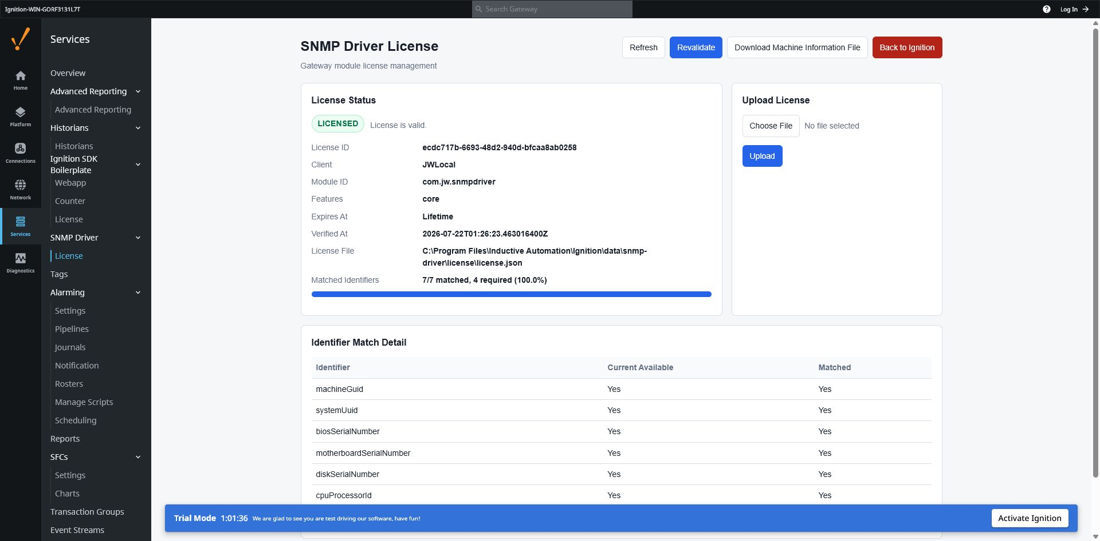
Figure 1. SNMP Driver License page after successful licensing.
Example values: License ID, client name, identifiers, and file paths are different on every installation.

1.2 Download machine information
STEP 1 — Download the file
Select Download Machine Information File.
STEP 2 — Find the download
The browser downloads snmp-driver-machine-information.txt. Do not edit this file.
STEP 3 — Send it for licensing
Send the TXT file to the internal application team with site/client basic info (project name/project job number).
STEP 4 — Wait for the license
The internal application team returns a license file in JSON format.
Protect the files: Machine information and license files are installation records. Store and send them only through approved company channels.

1.3 Upload the returned license
STEP 1 — Choose the JSON file
In Upload License, select Choose File and select the returned .json license file.
STEP 2 — Upload
Select Upload License.
STEP 3 — Confirm
If necessary, select Refresh or Revalidate. Confirm that License Status shows LICENSED.
Expected result: The status is LICENSED and no error message is shown.
If upload fails: Do not rename or edit the JSON content. Note the status code and message, then use the License status table in Appendix B.

2 Create an SNMP Device Connection
Create one Device Connection for each physical SNMP endpoint that must be managed separately.

2.1 Open Device Connections
STEP 1 — Open Connections
In the Gateway left navigation, open Connections.
STEP 2 — Open Devices
Select Devices to open the Device Connections page.
STEP 3 — Create a device
Select Create Device Connection, then select SNMP Device.
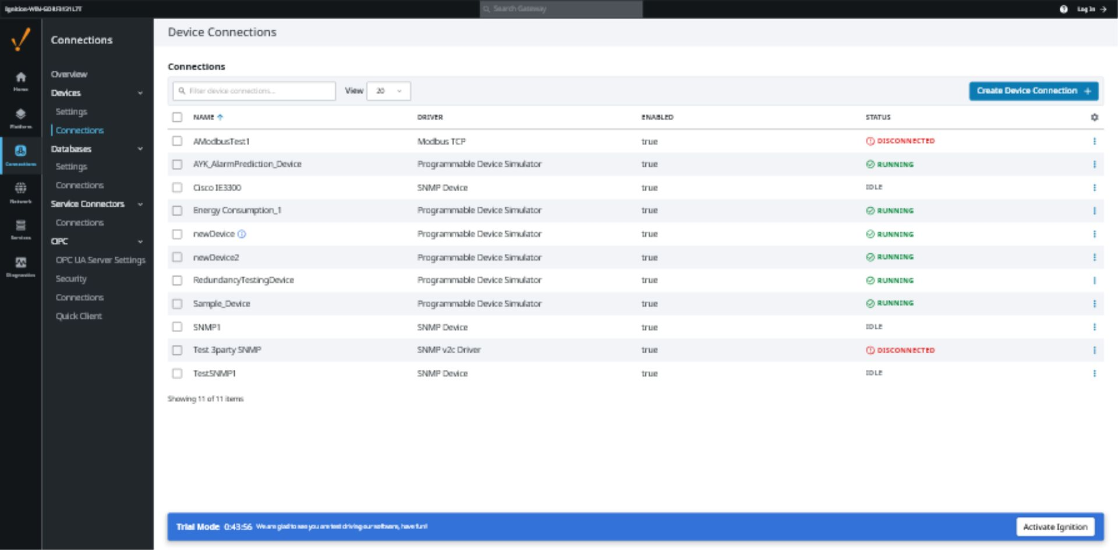
Figure 2. Gateway Device Connections page.
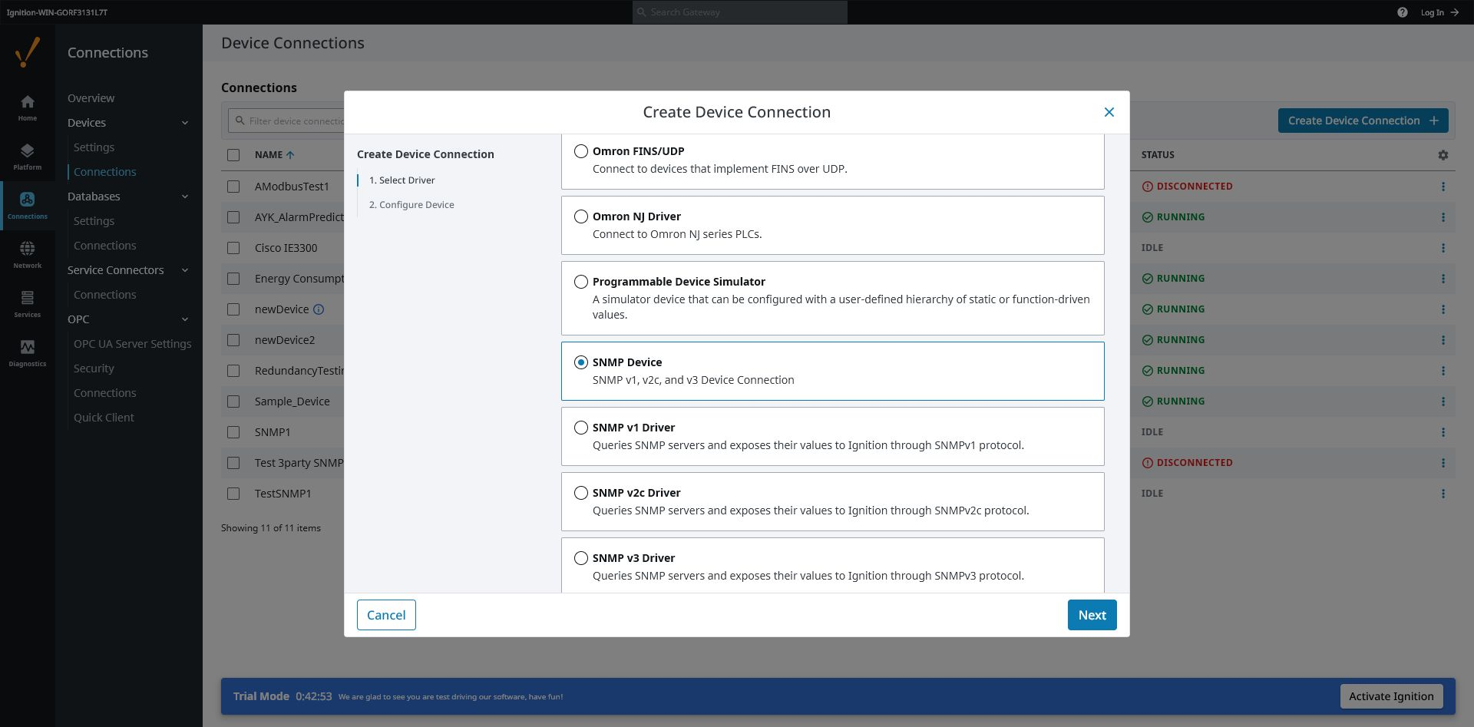
Figure 3. Select SNMP Device — SNMP v1, v2c, and v3 Device Connection.

2.2 Enter the connection settings
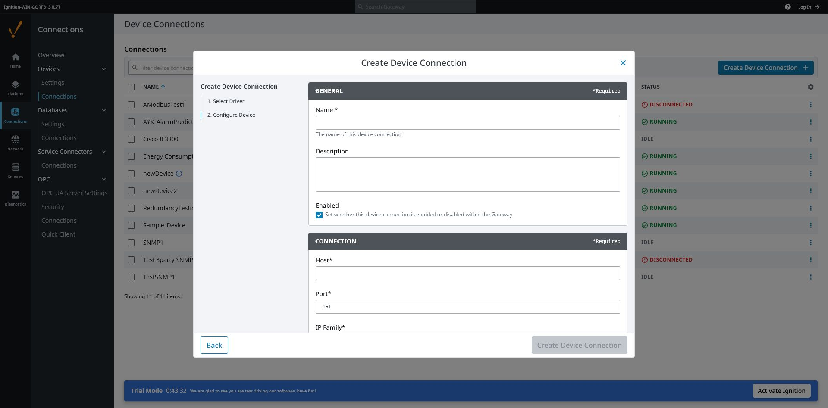
Figure 4. SNMP Device configuration form.
STEP 1 — Name the connection
Enter a short unique name. Use letters, numbers, and underscores where possible. This exact name becomes the [DeviceName] part of every OPC Item Path.
STEP 2 — Enter Host and Port
Enter the device IP address or DNS name. Leave Port at 161 unless the device supplier specifies another port.
STEP 3 — Select IP Family
Use AUTO unless the site specifically requires IPv4 or IPv6.
STEP 4 — Select SNMP Version
Select V1, V2C, or V3 to match the physical device. The security fields must match this choice.
STEP 5 — Set Access Mode
Use READ_ONLY for normal monitoring. Select READ_WRITE only when the Project Lead has approved SNMP writing.
STEP 6 — Review runtime settings
Keep the defaults unless the Project Lead or device documentation requires a change.
STEP 7 — Create the connection
Select Create Device Connection or Save Changes.
Expected result: The new connection appears in the Device Connections list.

2.3 Choose the correct security settings
Version / level | Required information | Simple guidance
SNMP v1 or v2c | Read Community | Required for reading. It is case-sensitive.
v1/v2c + READ_WRITE | Read Community + Write Community | Write Community is also required before any tag can write.
v3 NO_AUTH_NO_PRIV | Security Name | No authentication and no encryption. Use only when the device is configured this way.
v3 AUTH_NO_PRIV | Security Name, Auth Protocol, Auth Passphrase | Passphrase must contain at least 8 characters.
v3 AUTH_PRIV | Security Name, Auth details, Privacy Protocol, Privacy Passphrase | Default secure choice when it matches the device. Both passphrases need at least 8 characters.

Exact match required: SNMP Version, Security Level, protocols, names, passphrases, and Context Name must match the device configuration exactly.

Secret entry modes
Mode | Plain meaning | When to use
None | No secret is supplied. | Only when that field is not required for the selected SNMP version/security level.
Embedded | Enter the community or passphrase directly in this Device Connection. | Use when the approved secret is supplied for this connection.
Referenced | Use a secret stored separately in the Gateway. | Use when the Project Lead or Gateway Administrator provides a managed secret reference.

Do not expose secrets: Never place Community values or SNMPv3 passphrases in screenshots, manuals, log extracts, or handover notes.

2.4 Runtime settings — when to change them
Setting | Default | Plain meaning / field guidance
Timeout | 2000 ms | How long one request waits for a reply. Increase only for a known slow or high-latency network.
Retries | 1 | Number of extra attempts after a timeout. More retries can delay fault detection.
Max OIDs per Request | 25 | Maximum points combined into one request. Reduce if the device rejects large requests.
Max Request Bytes | 1200 | Size limit for one request. Reduce if the device reports message-size problems.
Max In-flight Requests | 2 | Number of simultaneous requests. Reduce for small or slow SNMP devices.

2.5 Full settings limits
Group | Field | Allowed value / important note
Connection | Host | Required; IP address or DNS name.
Connection | Port | 1 to 65535; default 161.
Connection | IP Family | AUTO, IPV4, or IPV6.
Protocol | SNMP Version | V1, V2C, or V3.
Protocol | Read / Write Community | Required according to v1/v2c access; case-sensitive.
v3 Security | Security Level | NO_AUTH_NO_PRIV, AUTH_NO_PRIV, or AUTH_PRIV.
v3 Security | Auth Protocol | MD5, SHA1, SHA224, SHA256, SHA384, or SHA512.
v3 Security | Privacy Protocol | DES, AES128, AES192, or AES256.
Access | Access Mode | READ_ONLY or READ_WRITE.
Runtime | Timeout | 100 to 60000 ms.
Runtime | Retries | 0 to 10.
Runtime | Max OIDs per Request | 1 to 100.
Runtime | Max Request Bytes | 484 to 65535.
Runtime | Max In-flight Requests | 1 to 8.

3 Confirm and Diagnose the Connection
A saved connection does not prove that the remote OID is readable. Use the status together with a real OPC Tag and the diagnostic values.

3.1 Read the Device Connection status
Use the STATUS column shown on the Device Connections page in Figure 2.
Status | What it means | What the Site Engineer should do
Starting | The driver is starting. | Wait a short time, then refresh.
Idle | Driver is ready, but no dynamic OID is currently subscribed. | This is normal before an OPC Tag is active. Create or enable a tag.
Connecting | At least one OID is active; the driver is waiting for a valid reply. | Check host, network, version, credentials, and OID if it does not change.
Running | At least one active OID has returned a valid SNMP reply. | Connection is operating. Confirm every required tag is Good.
Unlicensed | The module license is not usable. | Return to the License page and read the license status.
Degraded | Transport or resource failures opened the protection circuit. | Read Diagnostics and Logs. The driver retries automatically with increasing delay.
Errored | Initialization or an unexpected runtime error occurred. | Check the last error and Gateway logs; record the exact message.

Important: Idle is not a failure. It usually means no enabled OPC Tag is requesting a dynamic OID.

3.2 Read the Diagnostics tags
In Designer, browse the device in the OPC Browser. Open [DeviceName]/Diagnostics. These values explain what the driver is doing.
Where to look: Open the OPC Browser, expand Ignition OPC UA Server, expand the SNMP Device Connection name, then expand Diagnostics.
Diagnostic | Plain meaning
Status | Current driver state, such as Idle, Connecting, Running, Unlicensed, Degraded, or Errored.
ActiveSubscriptionCount | Number of active OPC UA subscriptions using this device.
ActiveOidCount | Number of different OIDs currently being polled.
MinimumEffectivePollInterval | Fastest active polling interval in milliseconds.
CircuitBreakerState | CLOSED = normal; OPEN = requests paused after repeated transport faults; HALF_OPEN = testing recovery.
LastSuccessTime | Most recent successful SNMP response.
LastFailureTime | Most recent failed SNMP request.
LastError | Most recent error message. Record this exact text when escalating.

3.3 Diagnose in the correct order
1. License — confirm the License page shows LICENSED.
2. Device status — decide whether Idle is expected or a failure state is present.
3. Diagnostics — check ActiveOidCount, LastSuccessTime, LastFailureTime, CircuitBreakerState, and LastError.
4. Tag Quality — read the exact quality code shown by the OPC Tag.
5. Gateway logs — open Diagnostics > Logs and filter using SNMP, the device name, or category=.
Record evidence: When escalating, provide Gateway time, device name, tag path, Tag Quality, LastError, and the matching log message. Do not include secrets.

4 Create an OPC Tag in Ignition Designer
A dynamic OID is normally entered manually because it may not appear as a pre-built point in the OPC Browser.

4.1 Open the project and Tag Browser
STEP 1 — Launch Designer
From the Gateway Home page, launch Ignition Designer and open the required project.
STEP 2 — Open the Tag Browser
Locate the Tag Browser panel. Select the required Tag Provider, normally [default] unless the project uses another provider.
STEP 3 — Choose the folder
Select or create the folder where the new SNMP tag will be stored.
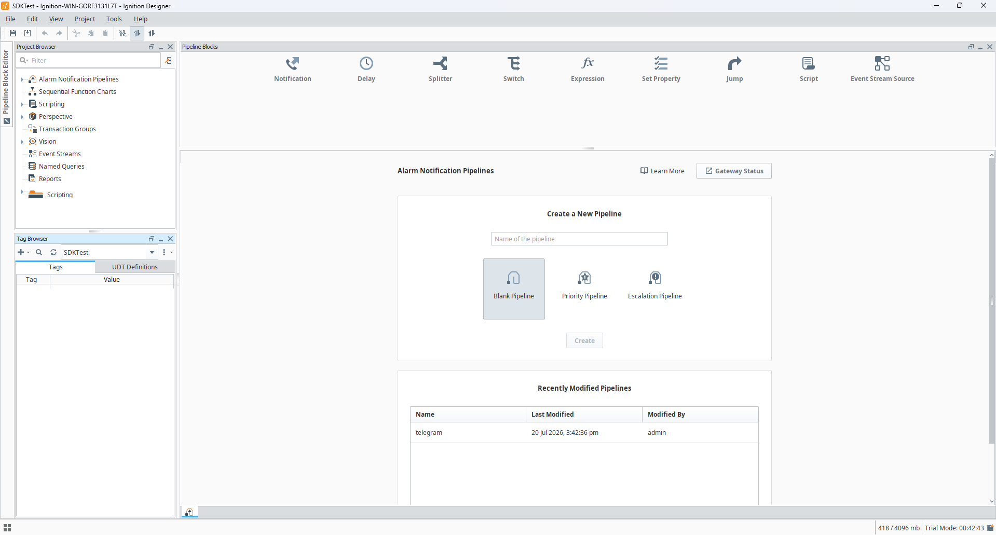
Figure 5. Designer Tag Browser and the target tag folder.

4.2 Create and configure the OPC Tag
STEP 1 — Create an OPC Tag
Right-click the target folder, select New Tag, then select OPC Tag.
STEP 2 — Set Name
Enter a clear point name, for example SystemUptime or PumpRunStatus.
STEP 3 — Set OPC Server
Select Ignition OPC UA Server.
STEP 4 — Enter OPC Item Path
Type the complete dynamic OID address. Examples are shown below.
STEP 5 — Set Data Type
Choose the Ignition tag data type that matches the dynamic OID type. Use the table in Chapter 5.
STEP 6 — Set Tag Group
Choose a Tag Group with a rate of 1000 ms or slower. Do not use a rate below 1000 ms.
STEP 7 — Save
Select OK or Apply.
Expected result: The tag appears in the Tag Browser and begins requesting the OID.
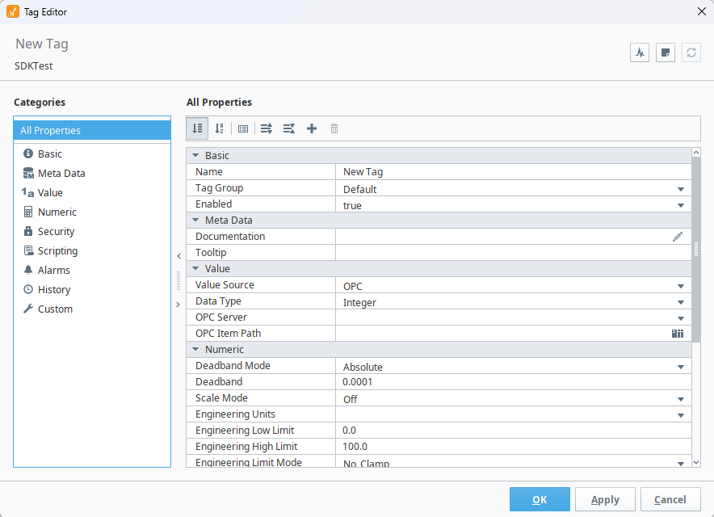
Figure 6. OPC Tag settings with a dynamic OID Item Path.

4.3 Confirm the result
What you see | Meaning | Next action
Good quality and a sensible value | The OID, type, security, and network path are working. | Compare the value with the device documentation or local display.
Bad_WaitingForInitialData | The first response has not arrived yet. | Wait one or two polling cycles. If it remains, inspect status and diagnostics.
Other Bad quality | Ignition rejected the path/type or the SNMP request failed. | Use the quality table in Appendix B.

5 Dynamic OID — Complete Setup Guide
The OPC Item Path has two parts: the exact Device Connection name inside square brackets, followed by the dynamic OID address.

5.1 Supported address formats
Use | Format after [DeviceName] | Example
Simple read-only string | <OID> | [Boiler_SNMP]1.3.6.1.2.1.1.5.0
Typed read-only | <Type>/<OID> | [Boiler_SNMP]TimeTicks/1.3.6.1.2.1.1.3.0
Explicit typed read-only | RO.<Type>/<OID> | [Boiler_SNMP]RO.OctetString/1.3.6.1.2.1.1.5.0
Typed read/write candidate | RW.<Type>/<OID> | [Boiler_SNMP]RW.Integer32/1.3.6.1.4.1.9999.1.0

Recommended: Use a typed form whenever the SNMP type is known. This gives correct numeric values and clearer type errors.

5.2 Build the OPC Item Path
STEP 1 — Copy the Device Connection name
Use the exact spelling and capitalisation shown in Gateway Device Connections.
STEP 2 — Confirm the numeric OID
Use a numeric dotted OID from approved device documentation. Do not use a symbolic MIB name.
STEP 3 — Choose the type
Select the matching type from the Supported types table below.
STEP 4 — Choose RO or RW
Use the default read-only format for monitoring. Use RW only when writing is approved and supported.
STEP 5 — Join the parts
Do not insert spaces, a question mark, or extra slashes.
[DeviceName]RO.Type/1.3.6.1.4.1.x.x.0

5.3 Syntax rules
Rule | Correct | Incorrect / reason
Numeric dotted OID only | 1.3.6.1.2.1.1.3.0 | sysUpTime.0 — symbolic names are not accepted.
Leading dot | .1.3.6.1.2.1.1.3.0 | Accepted; the driver removes the leading dot internally.
One slash in typed form | TimeTicks/1.3.6... | TimeTicks//1.3.6... — invalid.
Type required with RO/RW | RW.Integer32/1.3.6... | RW/1.3.6... — invalid.
No explicit String type | 1.3.6... or OctetString/1.3.6... | String/1.3.6... — not supported.
No spaces or query text | RO.Integer32/1.3.6... | RO. Integer32 / 1.3.6...? — invalid.

5.4 Supported types and matching Ignition data types
Dynamic OID type | Ignition / OPC UA type | Value guidance
Integer32 | Int32 | Signed whole number: -2147483648 to 2147483647.
Unsigned32 | UInt32 | Whole number: 0 to 4294967295.
Counter32 | UInt32 | Counter: 0 to 4294967295.
Gauge32 | UInt32 | Gauge: 0 to 4294967295.
TimeTicks | UInt32 | Hundredths of a second: 0 to 4294967295.
Counter64 | UInt64 | Large counter: 0 to 18446744073709551615.
OctetString | String | UTF-8 text.
ByteString | ByteString | Raw byte array.
ObjectIdentifier | String | Numeric dotted OID text.
IpAddress | String | IPv4 dotted address.
Opaque | ByteString | Raw opaque bytes.
OpaqueFloat | Float | 32-bit floating-point number.
OpaqueDouble | Double | 64-bit floating-point number.

Bare OID behavior: An address containing only the OID is read-only and returns the SNMP value as text. Use OctetString for known text, or a numeric type for numeric calculations.

5.5 Practical examples
Purpose | OPC Item Path | Suggested Tag type
System uptime | [Boiler_SNMP]TimeTicks/1.3.6.1.2.1.1.3.0 | UInt32
System name | [Boiler_SNMP]OctetString/1.3.6.1.2.1.1.5.0 | String
Simple text fallback | [Boiler_SNMP]1.3.6.1.2.1.1.1.0 | String
Vendor integer | [Boiler_SNMP]RO.Integer32/1.3.6.1.4.1.9999.1.0 | Int32
Approved setpoint | [Boiler_SNMP]RW.Integer32/1.3.6.1.4.1.9999.2.0 | Int32

Example only: The example enterprise OIDs are placeholders. Replace them with the approved OIDs for the actual device.

5.6 Polling rate
The driver accepts dynamic polling intervals of 1000 ms or slower. A faster rate is rejected; it is not silently changed.
Tag Group rate | Result | Guidance
1000 ms or slower | Supported | Choose the slowest rate that still meets the project requirement.
Below 1000 ms | Bad_OutOfRange | Move the tag to a Tag Group with a rate of at least 1000 ms.

6 Write to an SNMP OID — Only When Approved
Risk: An SNMP SET can change a real device. Confirm the approved OID, value range, operating condition, and rollback method before writing.
A write is allowed only when every gate below is satisfied.
Gate | Required condition
1. Device Connection | Access Mode is READ_WRITE.
2. Dynamic OID | OPC Item Path begins with RW.<Type>/ and contains a supported type.
3. SNMP credentials | v1/v2c has the correct Write Community, or v3 credentials have write permission.
4. Remote device | The OID is writable and the device permits the requested value.
5. Value | The value matches the configured type and allowed range.

If any gate fails, the tag may show Bad_NotWritable, Bad_UserAccessDenied, Bad_TypeMismatch, or another exact error.

Safe write procedure
1. Confirm written authorisation and the approved change window.
2. Record the present value and device operating state.
3. Write one tested value within the documented range.
4. Confirm Good quality and verify the device accepted the new value.
5. Record the result. If the write fails, stop repeated attempts and diagnose the exact quality code.

7 Troubleshooting

7.1 Fast symptom guide
Symptom | Most likely area | First checks
Device remains Idle | No active OID subscription | Create/enable an OPC Tag; check ActiveOidCount.
Device remains Connecting | Network, security, or OID | Host, firewall, SNMP version, credentials, OID, LastError.
Device is Unlicensed | License | License status code and message.
Device is Degraded | Repeated transport failure | CircuitBreakerState, LastFailureTime, LastError, logs.
Tag shows Bad_NodeIdInvalid | OPC Item Path syntax | Device name, slash count, type name, numeric OID.
Tag shows Bad_NodeIdUnknown | Remote OID missing | Correct OID and instance suffix, often .0 for scalar objects.
Tag shows Bad_TypeMismatch | Wrong dynamic type / Tag type | OID's real SNMP type and Ignition Data Type.
Read works but write fails | Write gates | READ_WRITE, RW.Type, Write Community/v3 permission, writable OID.

7.2 Network and security checks
- Confirm the IP address or DNS name belongs to the correct physical device.
- Confirm UDP port 161, or the site-specific SNMP port, is allowed between Gateway and device.
- Confirm the device's SNMP service is enabled and allows the Gateway IP address.
- Confirm SNMP version and every credential are case-sensitive and exactly matched.
- For SNMPv3, confirm Security Level, authentication protocol, privacy protocol, passphrases, and Context Name.
Protection circuit: After repeated transport failures, the driver temporarily pauses requests and retries with increasing delay up to about one minute. Use the Diagnostics state instead of repeatedly recreating the connection.

7.3 Gateway logs
STEP 1 — Open logs
In the Gateway, open Diagnostics, then Logs.
STEP 2 — Filter
Search for SNMP, the Device Connection name, or category=.
STEP 3 — Match the time
Use the same time shown in LastFailureTime or when the tag quality changed.
STEP 4 — Record the message
Copy the full error message and category. Remove credentials before sharing.

7.4 Escalation checklist
Provide | Example / note
Gateway and time | Gateway host name and local date/time of failure.
Device Connection | Exact connection name and status.
Safe connection details | Host, port, version, Security Level — never send passphrases or communities.
OPC Item Path | Full path including [DeviceName], type, and OID.
Tag Quality | Exact code, for example Bad_Timeout.
Diagnostics | ActiveOidCount, CircuitBreakerState, LastSuccessTime, LastFailureTime, LastError.
Logs | Matching category and complete error message.

8 Site Completion Checklist
Complete this checklist before handing the connection to the project team.
□ License page shows LICENSED.
□ Device Connection name follows the site naming standard.
□ Host, port, IP family, SNMP version, and credentials match the approved device configuration.
□ Access Mode is READ_ONLY unless writing is formally approved.
□ At least one real dynamic OID OPC Tag has Good quality.
□ Device status changes from Idle/Connecting to Running when the tag is active.
□ Tag Data Type matches the selected dynamic OID type.
□ Tag Group polling rate is 1000 ms or slower.
□ Read values are compared with device documentation or a known reference.
□ Diagnostics and Gateway logs contain no unresolved repeated error.
□ No password, community, or passphrase appears in screenshots or handover notes.
Handover complete: Record the final Gateway, Device Connection name, tag folder, tested OIDs, and outstanding limitations in the project handover record.

Appendix A Connection Settings Reference
Field | Default | Required / allowed
Host | Blank | Required.
Port | 161 | 1–65535.
IP Family | AUTO | AUTO, IPV4, IPV6.
SNMP Version | V3 | V1, V2C, V3.
Read Community | Blank | Required for v1/v2c reads.
Write Community | Blank | Required for v1/v2c READ_WRITE.
Security Name | Blank | Required for v3.
Security Level | AUTH_PRIV | NO_AUTH_NO_PRIV, AUTH_NO_PRIV, AUTH_PRIV.
Auth Protocol | SHA256 | MD5, SHA1, SHA224, SHA256, SHA384, SHA512.
Auth Passphrase | Blank | At least 8 characters when authentication is used.
Privacy Protocol | AES128 | DES, AES128, AES192, AES256.
Privacy Passphrase | Blank | At least 8 characters when privacy is used.
Context Name | Blank | Optional; use exact device context if required.
Access Mode | READ_ONLY | READ_ONLY, READ_WRITE.
Timeout | 2000 ms | 100–60000 ms.
Retries | 1 | 0–10.
Max OIDs per Request | 25 | 1–100.
Max Request Bytes | 1200 | 484–65535.
Max In-flight Requests | 2 | 1–8.

Appendix B Status and Error Code Reference

B.1 License status codes
Code | Plain meaning / action
LICENSED | License is valid. Continue to the Device Connection.
UNVERIFIED | License has not yet been verified. Select Revalidate or check logs.
MISSING_FILE | No license file exists. Upload the returned JSON license.
INVALID_FILE | The license file cannot be read. Obtain a fresh file; do not edit it.
INVALID_JSON | The file is not valid JSON. Obtain a fresh license file.
UNSUPPORTED_SCHEMA_VERSION | The license format is not supported by this module version. Contact licensing support.
UNSUPPORTED_ALGORITHM | The license uses an unsupported signature algorithm. Contact licensing support.
INVALID_SIGNATURE | The digital signature is not valid. Do not use or edit the file; contact licensing support.
INVALID_PAYLOAD | Required license content is missing or invalid. Contact licensing support.
WRONG_MODULE | The file was created for a different module. Request a license for SNMP Driver.
EXPIRED | The license expiry time has passed or is invalid. Request a renewed license.
INSUFFICIENT_MACHINE_INFO | The license does not contain enough machine identifiers. Send a new machine information file.
MACHINE_MISMATCH | The license belongs to another Gateway machine. Download current machine information and request a new license.
IO_ERROR | The Gateway could not read or write the license file. Record the message and check Gateway logs/permissions.
LICENSE_VERSION_NOT_MATCH | The license signing key/version does not match. Request a compatible license.

B.2 Common OPC Tag Quality codes
Quality code | Meaning | First action
Good | A usable value was received. | Compare value with expected device data.
Bad_WaitingForInitialData | No first value yet. | Wait one or two cycles; inspect status if it remains.
Bad_NodeIdInvalid | Dynamic OID path is invalid. | Check DeviceName, type, slash, spaces, and numeric OID.
Bad_NodeIdUnknown | Remote device reports no such object or instance. | Check OID and instance suffix.
Bad_TypeMismatch | Selected dynamic type or Tag Data Type is wrong. | Confirm actual SNMP type and update both types.
Bad_OutOfRange | Polling rate or value is outside the allowed range. | Use ≥1000 ms polling; check numeric limits.
Bad_LicenseNotAvailable | No usable module license. | Open License page.
Bad_LicenseExpired | Module license expired. | Request renewal.
Bad_Timeout | SNMP device did not reply in time. | Check network, port, device service, and timeout.
Bad_NoCommunication | DNS or transport failed. | Check host, route, firewall, and SNMP service.
Bad_SecurityChecksFailed | SNMPv3 security check failed. | Check v3 name, level, protocols, passphrases, and context.
Bad_NotWritable | Write is not enabled or OID is read-only. | Check READ_WRITE, RW.Type, and remote OID.
Bad_UserAccessDenied | Credentials do not allow the requested action. | Check Write Community or v3 user permission.

References
Product behaviour in this manual is based on the installed SNMP Driver module and the Ignition 8.3 documentation available when Rev 1.0 was prepared.
Reference | Use
Ignition 8.3 User Manual — Devices | Creating and managing OPC UA Device Connections.
Ignition 8.3 User Manual — OPC Tags | Manual OPC Tag properties, OPC Server, and OPC Item Path.
SNMP Driver module implementation | Dynamic OID syntax, supported data types, statuses, diagnostics, limits, and error mapping.

Revision note: Gateway screens can change after an Ignition or module upgrade. The workflow and exact field names should be reviewed when the installed version changes.

